Basic audits 2024-25

Application: Council subject to a Basic audit for 2024-25

The Auditor General’s right of access to information and explanations
Section 52 of the Public Audit (Wales) Act 2004 provides the Auditor General with the right of access to all information and explanations that he considers to be necessary for the purposes of the audit. Persons holding such information are required to provide this on request.
The following information is provided to assist councils to prepare information required for the audit of accounts.
Councils must note that this information request represents the core information we require. In most cases, this will be sufficient for us to complete the audit.
However, we may request any further information that we consider necessary to complete the audit. Further information may be required due to issues being identified or clarification being required during the audit process and/or if we receive correspondence related to individual councils.

Audit cycle
Your Council is subject to a ‘basic’ audit this year. The information required for audit can be seen below.
To view the audit cycle for the period 2024-25 to 2026-27, please refer to the attached document ‘TCC_audit_cycle_by_county.pdf’. It is arranged by county.

Information required

Council contact details and core information
Each year, we identify numerous changes to clerk’s/councils’ contact details. In many cases, councils do not inform us of these changes.
We will be asking all councils to confirm their contact details each year to help us maintain our records.
Page 5 sets out the contact details and other core information we require. All councils must complete this so that we can ensure our dataset is up to date.

Bank reconciliation
A bank reconciliation is a control schedule prepared by the Council that agrees the balance per the bank statement at the year end to the bank balance per the Council’s own records e.g. the cashbook. The Council should prepare a bank reconciliation every time it receives a bank statement to ensure that any errors are identified at an early stage.
The bank reconciliation(s) should cover all the Council's bank accounts. If the Council has more than one bank account it is helpful if you can provide a summary of the bank reconciliations that agrees to Box 8 on the Annual Return in addition to the detailed reconciliations prepared for each account.
If there are no outstanding items at the year-end you must still supply a bank reconciliation. A zero or “Nil” should be included in the relevant lines on the schedule or a clear statement should be made to that effect.
An example bank reconciliation is provided on page 4. We recommend that councils use this format.

Explanations of significant variances on the Accounting Statements
We require explanations for significant variances (increases or decreases) of more than 15% between the current audit year and the last audit year in lines 3, 4, 5, 6, 8, 10, 12 and 13. Variances of less than 15% need not be explained.
Positive and negative variances must be explained.
Your explanations must be quantified, i.e. state how much of the variance is covered by each specific explanation. Your explanations must ensure that the variances for each line are explained and quantified to within 15%.
You can set out your explanations of variances in any way you wish, but they should be clear and complete and easy to follow. You should not simply send a copy of a cashbook. We need to understand why the council’s activity level changed.
Our suggested method of how to identify variances that require explanation, and suggested layout for providing explanations are set out on pages 7 and 8.

Well-being of Future Generations (Wales) Act 2015
For those councils subject to the requirements of the Well-being of Future Generations (Wales) Act 2015, a copy of the Council’s report on how it is contributing to the wellbeing of its area.

Council contact details and other core information
Please provide the following contact details for the Council.
 | Current details
Clerk’s name | Vanessa Owens
Clerk’s address | LLanina  Aberporth  Cardigan  Ceredigion SA43 2EY
Clerk’s contact telephone | 07974203864
Clerk’s email address | Clerk@aberporthcommunitycouncil.gov.uk
Council website | www.aberporthcommunitycouncil.gov.uk

Accounting records
Please indicate the format in which the Council keeps its accounting records
 | Yes / No
Manuscript cashbook / receipts and payments book
Spreadsheet
Accounts software packages:
- Rialtas
- Sage
- Scribe | Yes
- Xero
- Other (Please specify)

Bank reconciliation
COUNCIL NAME: …Aberporth Community Council
COUNTY : …Ceredigion
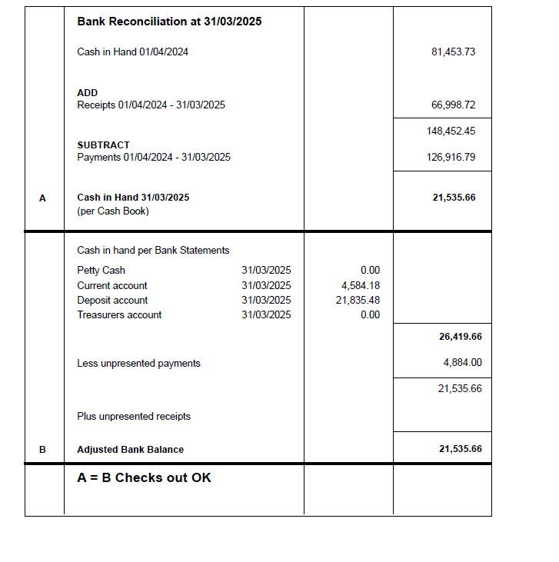

Explanation of variances

Working out what variances need to be explained
Line in section 1 | Last Year £ | This Year £ | Variance  Increase (+) or decrease (-)  (This Year minus Last Year)  £ | % (Variance divided by Last Year figure multiplied by 100) | Explanation required?  Less than 15% - NO  More than 15% - YES
Line 3
Total other receipts
Line 4
Staff costs
Line 5
Loan interest/ capital repayments
Line 6
Total other payments
Line 8
Debtors and stock balances
Line 10
Creditors
Line 12
Total fixed assets and long term assets
Line 13
Total borrowing

Suggested layout for explanations

One sheet to be prepared for each variance that requires explanation.

Line ……………….. | £
Figure in This Year column
Figure in Last Year column
Variance (This Year figure less Last Year figure) A positive figure is an increase, a negative figure is a decrease
Reasons (as many as are applicable) | Amount  £
Reason 1
Reason 2
Reason 3
Reason 4
Unexplained
Confirm unexplained amount is less than 15% of Last Year figure

Please note that explanations should be quantified and should consider one off items in both the current and prior years. Explanations that do not quantify each element of the variance will not be accepted as a full explanation and will likely result in a qualified opinion. Examples of unacceptable explanations include:
- Expenditure increased because the Council spent more on staff.
- Other payments increased because of park benches and grass cutting,

Governance themes 2024-25

Capital projects
Please provide the following information:
- Details of capital projects undertaking during the year. This should include project name and spend in year. If none, please state that this is the case.
- A copy of the minutes of the meeting at which the project contract was approved.

Member and officer training
Please provide the following information:
- A copy of the Council’s training plan.

Completion of audit 2023-24
Please provide the following information:
- Link to the Council’s website page where the audit completion notice for 2023-24 has been published or:
- If the 2023-24 audit is not complete, link to the Council’s website page where the latest audit completion notice has been published.
PLEASE NOTE THAT FOR THIS ITEM WE WANT A LINK TO YOUR WEBSITE NOT A COPY OF THE DOCUMENT

We will use this address to return any original records to you. The address you provide must be listed on Postcode finder. We cannot return documents to a PO Box.
The bank reconciliation provided must equal line 9 on the annual return. Therefore, you need to either provide a reconciliation for every account held by the Council or combine them all on one sheet.

