Reporting on Section 6
Community and Town Councils

Environment (Wales) Act 2016 Part 1 – Section 6
The Biodiversity and Resilience of Ecosystems Duty

The Biodiversity and Resilience of Ecosystems Duty
Report 2025
Name of Community or Town Council: | Cyngor Cymuned Aberporth Community Council
Group: | 3
Introduction and Context
Aberporth Community Council serves the communities of Aberporth, Parcllyn, Blaenporth & Blaenannerch.

The community council consists of 12 councillors and a part time Clerk & RFO.

As a Group 3 council, it has land management responsibilities and is committed to enhancing biodiversity through community engagement, partnerships, and land stewardship.

The Council administers local facilities and projects, supports community events, and liaises with residents and partner organisations to promote well-being and sustainability. While not subject to the Well-being of Future Generations Act directly, the Council supports its principles.

Contextual features:
Population: ~2,500
Precept: £57873

Land includes open spaces belonging to Aberporth Village Hall, footpaths, play areas, and the newly acquired land at Parcllyn, with potential for biodiversity improvements and community benefit.

Planters and raised beds located through the village of Aberporth and Dyffryn Garden provide opportunities for pollinator-friendly and native planting.

The Council takes advice from One Voice Wales and Ceredigion County Council’s biodiversity officers and works with groups such as Aberporth Village Hall, Plastic Free Aberporth, Tidy Towns and local schools to promote biodiversity awareness and action.

Action Report 2023 - 2025
NRAP  Objective | Action carried out to… |  | Monitored by:
1 | -embed biodiversity into decision making & procurement | Aberporth Community Council embeds biodiversity considerations into its decision-making and procurement processes by prioritising sustainability, local sourcing, and environmentally responsible practices. The Council’s Procurement Policy ensures that environmental impacts are assessed when purchasing goods and services, favouring suppliers that use sustainable materials and methods. By aligning procurement with its Environment and Sustainability Policy, the Council supports actions that minimise waste, reduce carbon emissions, and promote biodiversity-friendly outcomes across its projects and operations.  Biodiversity is included as a monthly agenda item and Cllr Gethin Davies is appointed as lead councillor on Biodiversity.  The Footpath & Maintenance committee responsibilities include the upkeep of public spaces, play areas, footpaths, and community assets; overseeing planting schemes and ensuring facilities are well maintained for public use. The Committee plays a key role in embedding sustainable and biodiversity-friendly practices in grounds maintenance.  In assessing planning applications, the Planning Committee considers potential impacts on habitats, wildlife, and green spaces, ensuring developments align with sustainable planning principles and the objectives of national and local planning policies.  Clerk and Councillors have undertaken One Voice Wales Training relating to s6 plan and reporting; Biodiversity and Nature Project Management. | Clerk  Cllr Gethin Davies  Maintenance Committee  Full Council
1 | -raise awareness of biodiversity & its importance | Aberporth Community Council actively promotes awareness and understanding of biodiversity within the community through education, participation, and practical activities. The Council integrates biodiversity-themed initiatives into local events, encouraging engagement through activities such as building bug and bee houses, creating wildflower seed bombs, designing eco-friendly shopping bags, making bird feeders, and constructing hedgehog houses for local schools. Informative displays about local wildlife are provided at beaches, alongside regular beach cleaning events that highlight the link between marine litter and ecosystem health. The Council also supports Plastic Free Aberporth, helping to reduce plastic pollution and protect the coastal and marine environment.  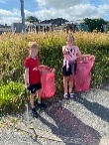  The Council also supports the Tidy Town initiative and recognises the valuable contribution of residents who carry out daily litter picking, helping to maintain a cleaner environment that supports local wildlife  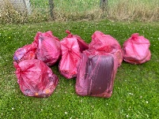  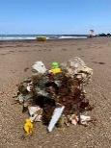  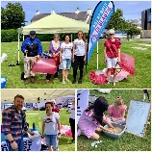  Through these hands-on and collaborative initiatives, the Council fosters a deeper appreciation of local biodiversity and empowers residents of all ages to take positive environmental action.
2 | -safeguard principal species and habitats | The community council is fortunate to have the support of a local resident who monitors the local biodiversity and reports to the council. Please see updated report here:  http://www.aberporthcommunitycouncil.gov.uk/_UserFiles/Files/Aberporth%20Biodiversity%20Status%20Report%202%20-%20November%202025%20Update.pdf          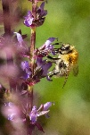  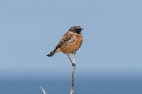  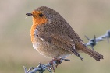  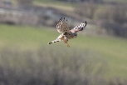  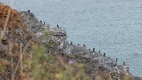  Use the LERC Wales App: This is the recommended bilingual app for smartphones (available on the Apple App Store and Android Play Store) that allows you to record sightings with GPS coordinates and photos. The data is held within the iRecord system and shared our local LERC.
3 | -restore & create habitats and resilient ecological networks | Aberporth Village Hall has prepared a Landscape and Ecological Management Plan for its community land, supporting the restoration and creation of habitats across amenity grassland, woodland, and semi-improved grassland areas. Aberporth Community Council contributes to this effort by managing the grass cutting of the Village Hall’s amenity land at Lower Welfare Park, including the play area and surrounding areas near the car parks and beaches. The Council also manages grass cutting and maintenance at Brynglas Play Area, Parcllyn Play Area, areas on housing estates, and selected roadside verges to maintain safe and attractive green spaces while supporting biodiversity where possible. In April 2025, the Council purchased the land known as the “Football Field” in Parcllyn from the Ministry of Defence and is developing plans for this site, including proposals for tree planting and the creation of a community garden to further enhance local habitats and strengthen ecological connectivity.  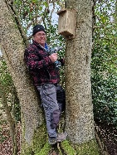  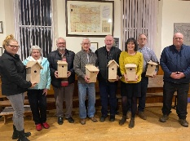  Aberporth Community Council has supported the installation of nest boxes in local woodlands as part of an initiative to enhance nesting opportunities for small woodland birds. The majority of these boxes were quickly adopted and successfully used demonstrating the success of the project in providing much-needed breeding sites. This initiative has contributed to increasing bird populations in areas previously lacking suitable nest holes and is also expected to benefit wider woodland biodiversity by supporting a greater number of natural predators. Building on this success, the Council plans to extend the nest box scheme to other suitable local areas and explore opportunities to provide nesting support for additional bird species that face shortages of appropriate nesting sites.  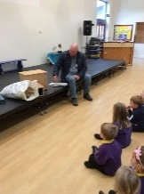  Local schools were also provided with hedgehog houses for their outside spaces.  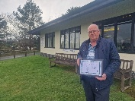  The community council won a One Voice Wales award for this initiative.
4 | -tackle negative factors: for e.g. reduce pollution, use nature-based solutions, address invasive species | Aberporth Community Council takes active steps to address factors that negatively impact local biodiversity, including pollution, habitat degradation, and invasive species.  The Council promotes and supports community-led initiatives such as regular beach cleaning, Tidy Town events, and daily litter picking by residents to help reduce pollution and protect marine and coastal habitats.  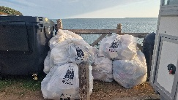  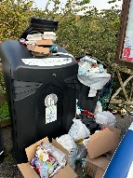  A partnership to manage tourism waste issues has been achieved with Ceredigion County Council and Aberporth Village Hall.  Nature-based solutions are encouraged through the creation of pollinator-friendly planting, wildflower areas, and tree planting projects that enhance natural resilience and carbon capture. The Council also works in partnership with Aberporth Village Hall and Ceredigion County Council to monitor and manage invasive species, including the ongoing control of Japanese Knotweed. Through these practical and collaborative actions, the Council helps maintain a cleaner, healthier environment that supports wildlife and strengthens local ecosystems.
5 | -use improve and share evidence | Aberporth Community Council collects and shares evidence of its biodiversity and environmental work to promote transparency, learning, and community engagement. Reports, such as the S6 Biodiversity Report, Biodiversity Action Plan and project updates, are made available on the Council’s website to demonstrate progress and good practice. Photographs and updates from biodiversity projects, events, and community activities are regularly featured in newsletters and on social media, helping to raise awareness and celebrate local achievements. This open sharing of evidence helps inspire further community involvement and supports the continuous improvement of the Council’s environmental initiatives.
6 | -support capacity and/or other organisations | Ceredigion County Council Ceredigion Nature Partnership for advice and joint project working.  One Voice Wales for Biodiversity training also support and advice from Local Places for Nature Project.  Aberporth Village Hall joint land management for public spaces.  Keep Wales Tidy Established Tidy Town groups that manage litter picking projects.  Plastic Free Aberporth to promote and support work in achieving plastic free status.  Residents raising awareness on local projects and opportunities to engage with biodiversity initiatives.

Review of S6 duty actions for 2023-2025
What has worked well? | - Successful installation of bird nest boxes in local woodlands, quickly adopted by birds.  - Biodiversity-themed community events engaging residents through bug and bee house building, wildlife crafts, and hedgehog house projects for local schools.  - Partnership working with Aberporth Village Hall to restore and manage habitats, improving ecological connectivity.  - Ongoing Tidy Town activities, beach cleans, and daily litter picking by residents reducing pollution and improving local habitats.  - Regular sharing of biodiversity updates, reports, and photos via the Council website, newsletters, and social media to raise awareness and celebrate success.
What have the barriers been? | - Coordination with partner organisations: Aligning biodiversity activities and maintenance schedules with Aberporth Village Hall’s land management.  - Limited resources and capacity: Availability of volunteer time and funding can restrict the scale and speed of biodiversity projects and maintenance work.  - Balancing public access with habitat protection: Ensuring community spaces remain accessible for recreation while protecting sensitive habitats has been an ongoing challenge.  - Weather and seasonal constraints: Wet or unpredictable weather conditions can delay planting, habitat restoration, or community engagement events.  - Management of invasive species: Ongoing control of Japanese Knotweed and other invasives requires long-term monitoring and collaboration with external partners.  - Awareness and engagement: Sustaining community participation and understanding of biodiversity priorities requires continued communication and education efforts.
What will you change? | - Improve coordination with Aberporth Village Hall to ensure biodiversity work and land management activities complement each other.  - Develop a clear annual maintenance and biodiversity action schedule to better align planting, grass cutting, and habitat management across community sites.  - Increase volunteer recruitment and training to build local capacity for biodiversity projects.  - Enhance communication and awareness campaigns through newsletters, social media, and signage to encourage wider community participation.  - Expand the nest box scheme to include other bird species and additional locations within the community.  - Adopt more nature-based management practices, such as creating more wildflower areas and reducing mowing in suitable zones.  - Strengthen monitoring and evidence sharing by collecting more data, photographs, and feedback to inform future actions and demonstrate impact.
How and when will the s6 duty be monitored and the s6 plan reviewed? | Aberporth Community Council will monitor delivery of its Section 6 (S6) biodiversity duty on an annual basis, reviewing progress against the actions and objectives set out in its Biodiversity Plan. Updates and evidence of activities will be gathered throughout the year and reported to Council as part of its annual review of environmental and community projects. A new S6 Biodiversity Plan for 2026–2028 will be prepared and formally approved by the Council to ensure continued progress, alignment with emerging priorities, and ongoing compliance with the Environment (Wales) Act 2016.

Back

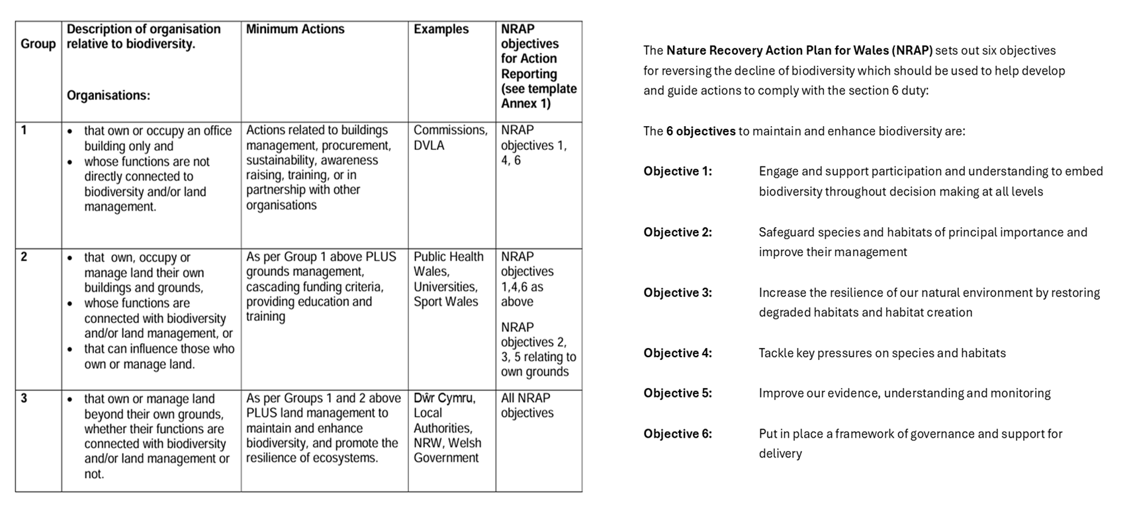

Adrodd ar Adran 6
Cynghorau Tref a Chynghorau Cymuned

Deddf yr Amgylchedd (Cymru) 2016 Rhan 1 – Adran 6
Y Ddyletswydd Bioamrywiaeth a Chydnerthedd Ecosystemau

Adroddiad 2025
Ddyletswydd Bioamrywiaeth a Chydnerthedd Ecosystemau

Enw y Cyngor Tref neu Gymuned:
Grŵp:
Cyflwyniad a'r Cyd-destun
- Disgrifiad byr o'r Cyngor, ei swyddogaethau a'r cyd-destun o ran
- sut y gallai helpu bioamrywiaeth (trwy ei swyddogaethau rheoli tir, cyllid grant, gweithgareddau addysgol e.e.)

- graddfa ofodol a lle (e.e. faint o dir mae'n ei gynnwys, poblogaeth, praesept?)

- cyflawni gwasanaethau i'r cyhoedd (e.e. a yw'n destun Ddeddf Llesiant Cenedlaethau'r Dyfodol?)

Adroddiad Gweithredu 2023 – 2025
Amcan NRAP | Camau gweithredu i... |  | Wedi eu monitro gan:
1 | -cynnwys bioamrywiaeth o fewn llunio penderfyniadau a chaffael
1 | -codi ymwybyddiaeth o fioamrywiaeth a'i bwysigrwydd
2 | -diogelu prif rywogaethau a chynefinoedd
3 | -adfer & chreu cynefinoedd a rhwydweithiau ecolegol cydnerth
4 | -mynd i'r afael ag elfennau negyddol: lleihau llygredd e.e. defnyddio atebion yn seiliedig ar natur, mynd i'r afael â rhywogaethau goresgynnol
5 | -defnyddio gwella a rhannu tystiolaeth
6 | -cefnogi capasiti ac/neu sefydliadau eraill

Arolwg o ddyletswydd Adran 6 2023 - 2025
Beth sydd wedi gweithio'n dda?

Beth fu'r rhwystrau?
Beth fyddwch yn ei newid?
Sut a phryd fydd y ddyletswydd Adran 6 yn cael ei monitro a'r cynllun Adran 6 wedi'i adolygu?

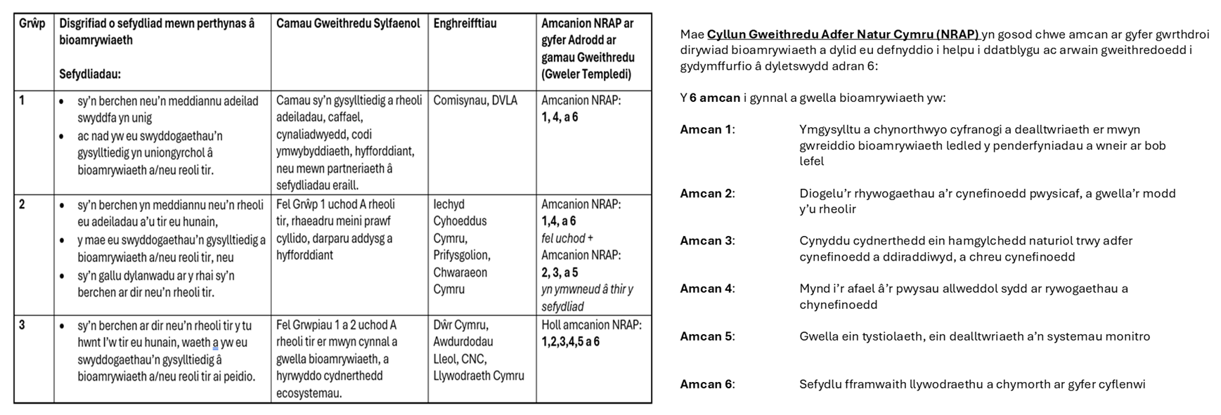
Nôl

