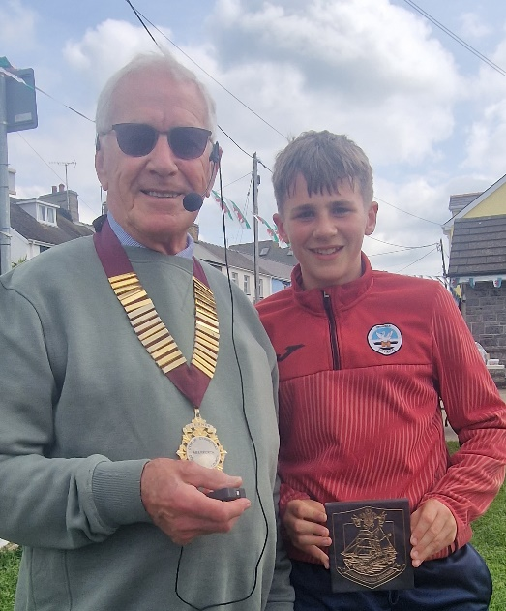
Dylan Pritchard-Evans is presented with a plaque; by the Chairman; in recognition of the bravery shown in averting a potentially serious accident on the M4 in January 2022.

